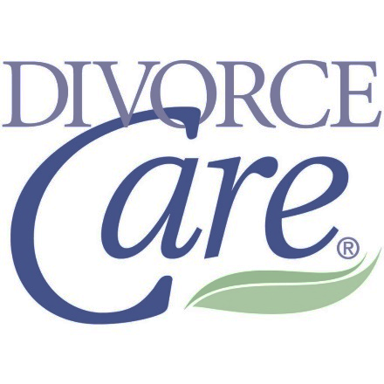

Divorce Care Online

If your family has been touched by divorce and you are looking for healing and a way to help your children heal and be able to move on, then this program is for you!

Divorce Care is a healing ministry from Church Initiative Sponsored and presented by St Paul UMC. Our team looks forward to meeting with you on the Zoom platform every Monday night from 7:00 - 9:00.

This is a good opportunity for those with children to participate in the comfort of their Home surroundings. Another positive is we do not have to cancel for weather.

Todd Seidel Administrator
(717) 487-8987
justicetod@aol.com

